**Analyzing profiles of 2019 general election candidates using attributes like criminal cases, caste category etc.**

**Team Name** – Vision Quest

**Team Lead** – Kirandeep Kaur (33)

**Team Member** –

Pritika Sarkar (39)

Shivam Nanda (50)

Vidhi Agrawal (59)

Yash Agrawal (60)

**Problem Statement:**

**Predicting the winner for General Elections in India using K-Nearest Neighbor (KNN) algorithm.**

* We decided to work on 2019 Election data to gain new insights on the political candidates.
* The background information on each political candidate provided some stereo type breaking results.

**STAKE HOLDER MAP:**

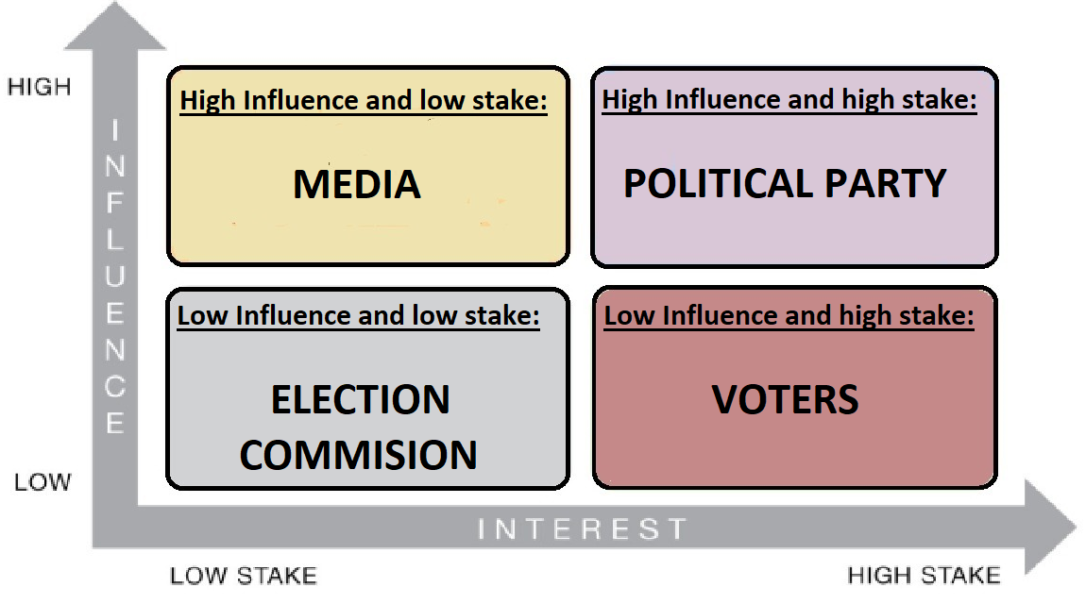

**SECONDARY RESEARCH:**

**Solution**

* Data Extraction from Kaggle.
* Data Cleaning:

1. Removing null values

2. Removing irrelevant attributes from dataset

3. Encoding/Labelling non-numeric data.

* Calculating Multicollinearity among the attributes.
* Normalization: Using min-max scaler.
* Application of KNN Model:

1. Separate train features and labels.

2. Split dataset into train and test data.

3. Train and test KNN model.

**Insights**

* According to our prediction, we have an accuracy of 75.27% in estimating the winning participant using KNN model. We will work to improve this model in the future updates.
* Our analysis from the prediction gives a complex political landscape of how different attributes like- criminal cases, category, party etc., affect the winning chances of a candidate.